Student Name: Vasukumar Patel
Student Number: 041153940
Lab Professor: Teddy Yap
Lab - 3

PART - 1

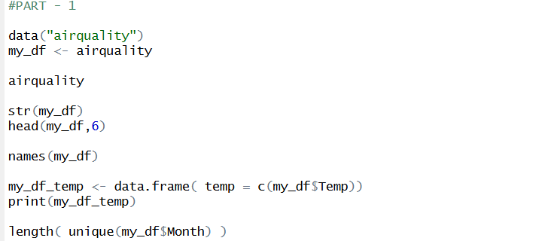

- How many months are in the data set?
- 5

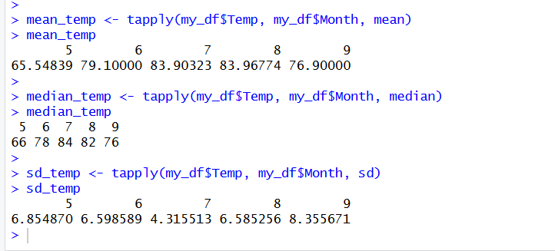

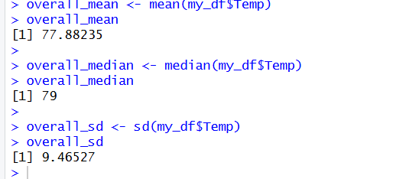

PART – 2
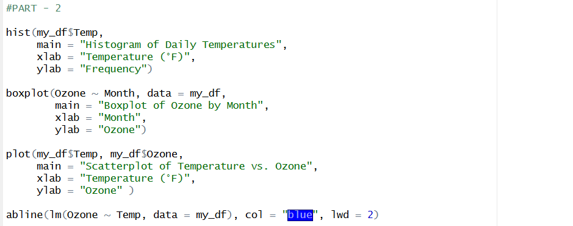

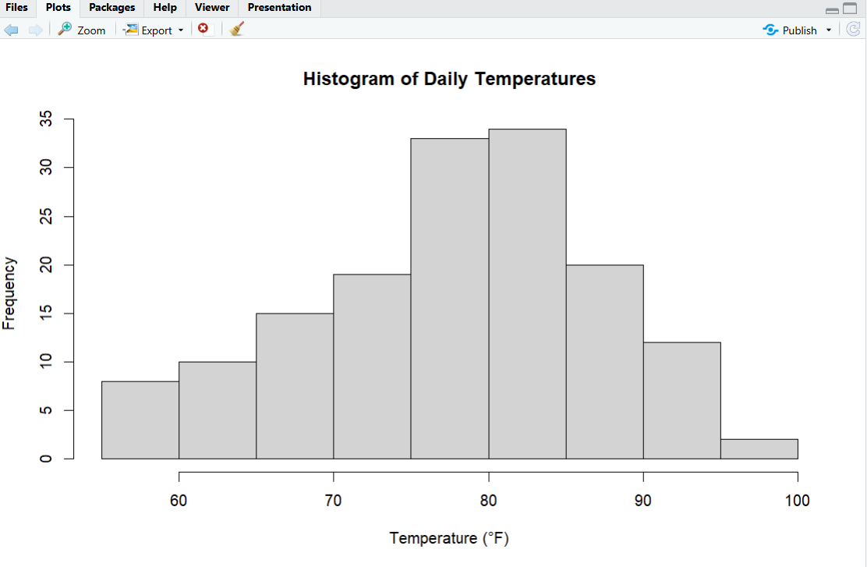

- The histogram shows how the daily temperatures are spread. It tells us which temperatures happened most often and which temperatures were less common.

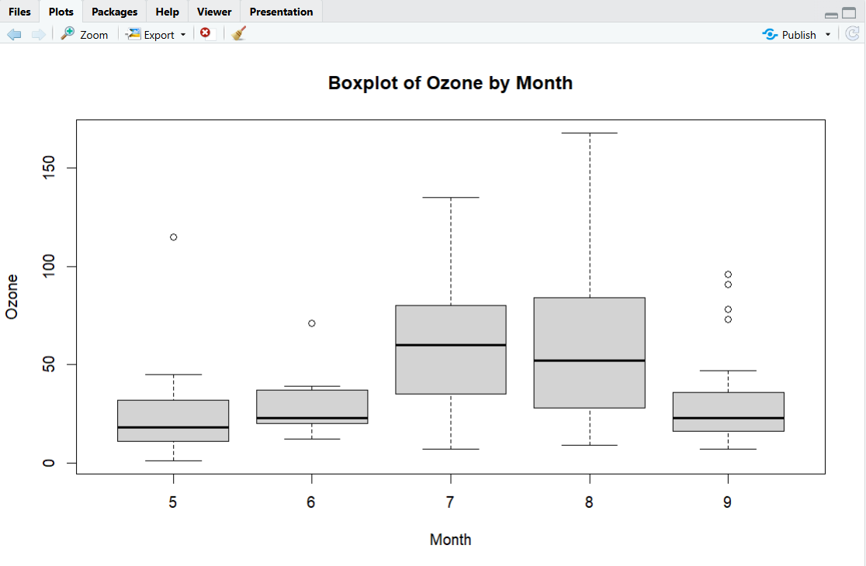

- The boxplot shows how Ozone levels are spread for each month. The middle line in each box is the median, the box shows the middle 50% of the data, and the whiskers show the lowest and highest values. Any dots outside the whiskers are outliers. This helps us see which months had higher or lower Ozone levels.

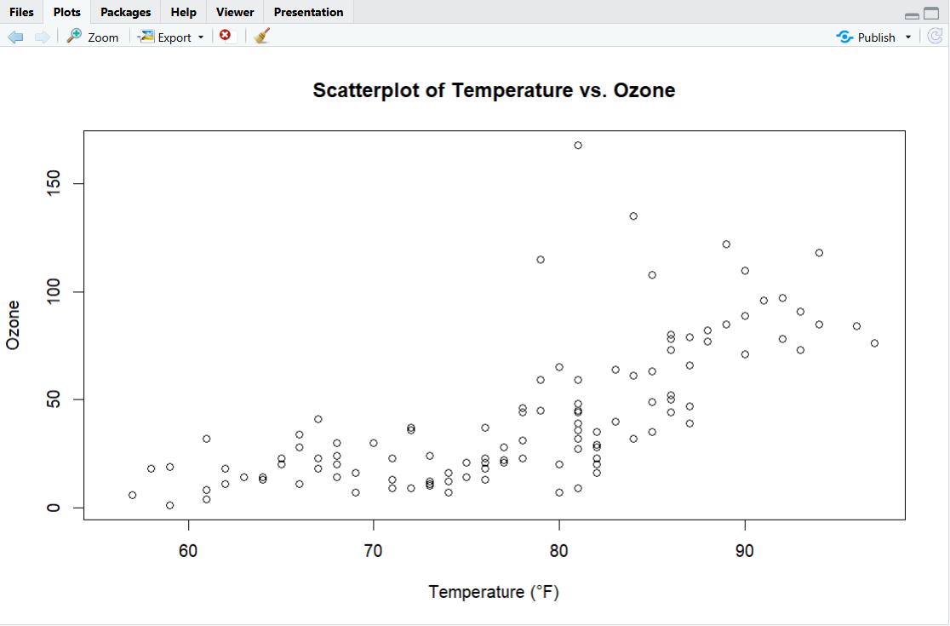

- The scatterplot shows the relationship between Temperature and Ozone levels. Each point represents one day. The x-axis is the temperature and the y-axis is the Ozone level. By looking at the plot, we can see if higher temperatures are related to higher or lower Ozone levels.

PART – 3

- The temperature data is almost symmetric, but the mean is slightly less than the median, so it shows a small left skew.
- Ozone tends to increase as Temperature increases. The blue regression line shows this trend clearly, making it easier to see the pattern in the scatterplot.

PART – 4

- The probability that the temperature during these months is less than 70.
- 0.2024884

- The probability that the temperature during these months is greater than 85.
- 0.226033

- The probability that the temperature during these months is less than 90 and greater than 75.
- 0.5194002

- Locate line 102 and explain the following. Provide your answers in the submitted PDF.
(3 points)

- which month this is for?
- August

- what the temperature is (in degrees F)?
- 92

- what does the z-score information tell us about this particular temperature value?
- 1.491521

